CAN and LIN bus technology

Introduction:

* An Electronic Control Unit, simply called ECU, generally consists of microcontroller(s), sensors, power switches, drivers and voltage regulator(s).
* Such a typical ECU is often used in the automotive domain.
* For a long time it was usual practice to connect the growing number of sensors and actuators directly to a central ECU.
* Automotive applications contains many ECUs, these ECUs communicate through different automotive bus protocols.CAN, LIN and FelxRays.

**Network Characteristics:**

1. Transmission Medium

* Single wire :Up to 50 Kb/s
* Two wires differential: Up to 125 Kb/s
* Two wires unshielded twisted: pair(UTP) Up to 500 Kb/s
* Two wires shielded twisted: pair(STP) Up to 10 Mb/s
* Optical fiber Up to 25 Mb/s

1. Line Coding:

* Return to Zero (RZ)

With RZ a '0' bit is represented by 0 volts whereas a '1' data bit is

represented by +V volts for half the cycle and 0 volts for the second

half of the cycle.

* Non returning to zero (NRZ)

NRZ encoding uses 0 volts for a data bit of '0' and a +V volts for a data

bit of '1'.

1. Data Packetization:

A packet is a basic unit of communication over a digital network.

A packet is also called a datagram, a segment, a block, a cell or a frame

Depending on the type of network.

Fram identification: massage id or destination id

1. Network Topology

* Ring topology
* Star topology
* Bus topology

5. Transmission Speed

* Transmission rate: is the theoretical rate at which user data can be

transmitted across a circuit.

* Bit rate: is the number of bits that pass a given point in a

telecommunication network in a given amount of time, usually a second.

* Baud rate: is the measurement of the number of times per second a

signal in a communications channel changes.

**Communication Terminologies**

1. Network Layers :TCP/IP Model

* Physical layer ( Driver) Performs the hardware access and details such as (electrical and mechanical connections to the network, transmission of binary data as changing voltage levels on wires or similar concepts on other connectors, and data rates) to the upper layer.
* Interface layer Provides the functional procedural means to transfer data between network entities and might provide the means to detect and possibly correct errors that may occur in the Physical Layer. Framing, Acknowledgment , Sequence Numbering, Error Detection, Retransmission and Flow Control.
* Transportation layer: Responsible of segmentation and reassembly f the messages that don’t fit in one Frame.

1. Synchronous/Asynchronous

* Synchronous transmissions: Synchronized by an external clock.The stream of data to be transferred is encoded as fluctuating voltages on one wire, and a periodic pulse of voltage is put on another wire (often called the "clock" or "strobe") that tells the receiver "here's where one bit/byte ends and the next one begins".
* Asynchronous transmissions: Synchronized by special signals along the transmission medium. There is only one wire/signal carrying the transmission. The transmitter sends a stream of data and periodically inserts a certain signal element into the stream which can be "seen" and distinguished by the receiver as a sync signal.

Examples

1. SPI (Serial Peripheral Interface Bus) Full duplex

Master device initiates the data frame.

Multiple slave devices are allowed with individual slave select (chip select)

lines.

1. I2C (Inter-Integrated Circuit)

Half duplex

Multi Master

1. UART (Universal asynchronous receiver/transmitter ) Serial Communication

TxD and RxD signals used to transmit/receive data

Start, Stop and Parity bits used for signaling

1. Protocol Orientations

Message Orientation

* Message ID is used to identify the message

All receivers receive the message and only the receiver who

interested in it will perform processing

Destination orientation

* Destination ID is used to identify the message

The destination should be known before sending

Only one receiver receive the message.

LIN(Local Interconnect Network)

Why LIN?

* Low Cost (cost reduction)
* Single Wire
* Low Baud Rate
* Low Speed Application
* (speed up to 20 kbit/s)
* Self Synchronization Mechanism
* Easy Implementation
* Quality Enhancement
* Single Master
* LIN is the communication protocol for a low-speed network to which all comfort and convenience applications in the car are connected.
* Instead of every air conditioning vent, electrical seat motor and sunroof being individually wired point-to-point to its own switches, only one wire can connect up to 16 separate points using „LIN“.
* LIN can be used for every application which has no demand for high data rates.

What is LIN?

LIN (Local Interconnect Network) is a low cost serial communication system for distributed electronic systems in vehicles. It complements the existing portfolio of automotive multiplex networks. LIN enables cost-effective communication for smart sensors and actuators where the bandwidth and versatility of CAN is not required.

The Key Features of LIN are:

* Low cost single-wire implementation
* Speed up to 20Kbit/s (limited for EMC reasons)
* Single Master/Multiple Slave Concept
* No arbitration required
* Low cost silicon implementation based on common UART/SCI interface hardware
* Self synchronization in the slave nodes without crystal or ceramics resonator
* Does LIN replace CAN?

No, LIN and CAN co exist in the automotive market.

LIN addresses an application space that requires less bandwidth and versatility when compared to the CAN application space.

* What are the target applications for LIN Bus?

Target automotive applications include mirrors, window lift, doors switches, door lock, HVAC motors, control panel, engine sensors, engine cooling fan, seat positioning motors, seat switches, wiper control, light switches, interface switches to radio/navigation/phone, rain sensor, light control, sun roof, RF receivers, body computer/smart junction box, interior lighting and more.

* Can LIN be used for non-automotive applications?

Although designed for automotive applications, LIN is not limited to automotive applications and has found it's way already into applications such as appliance and consumer.

CAN(controller area network)

* CAN is a serial bus protocol to connect individual systems and sensors as an alternative to conventional multi-wire looms. It allows automotive components to communicate on a single or dual-wire networked data bus up to 1Mbps
* Most motor vehicle CAN networks operate at a bus speed of 250KB/s or 500KB/s, although systems are available operating at up to 1MHz.
* Can used Arbitration : CAN uses the established method known as Carrier Sense, Multiple Access with Collision Detect (CSMA/CD)
* Bit encoding: CAN uses Non Return to Zero (NRZ)
* Message Frames: In a CAN system, data is transmitted and received using Message Frames. Message Frames carry data from a transmitting node to one, or more, receiving nodes.

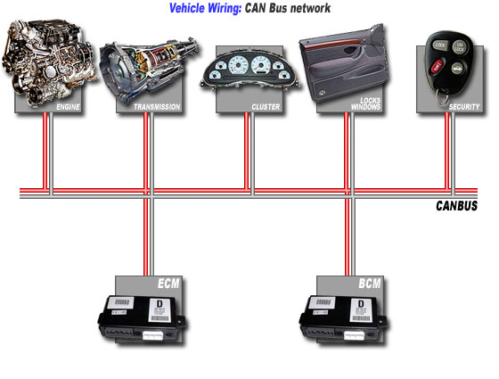

|  |  |  |
| --- | --- | --- |
|  | LIN | CAN |
| Master | Single master | Multi master |
| Bit rate | 1: 20 kb/s | 1k: 1Mb/s |
| Configuration | UART – SCI – Control | Control |
| Message format | 2,4,8 byte 🡪data  3 byte control | * Standard protocol   5 control   * Extended protocol   8 control  0-8 data for both |